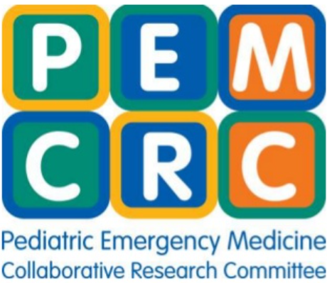

Call for Fellows to join the PEM CRC Steering Committee

What is the PEM CRC?
The Pediatric Emergency Medicine Collaborative Research Committee (PEM CRC) is a subcommittee of the AAP Section on Emergency Medicine that supports multicenter collaborative research in PEM.

Learn more at https://www.pemcollaborativeresearchcommitteepemcrc.org/

What is the PEM CRC Steering Committee?
The PEM CRC Steering Committee is currently made up of 10 established PEM investigators and 4 fellow representatives. The Steering Committee reviews network proposals, oversees the survey competition, and serves to mentor junior investigators.

What’s in it for me?
Two current first-year (rising second-year) fellows will be selected for the upcoming academic year, but those in other years of training may be considered. Fellow members serve for two years on the PEM CRC Steering Committee alongside a group of experienced PEM researchers and mentors. Fellows participate in review of multicenter and national survey study proposals for adoption by the PEM CRC, advocate for PEM fellow research involvement and training, and have opportunities for scholarly activity.

Responsibilities/Expectations
- Attend at least one PEM CRC meeting per year at the AAP or PAS conference
- Maintain membership in the AAP SOEM
- Participate in monthly PEM CRC Steering Committee conference calls
- Provide a voice for fellows’ needs and interests
- Plan the annual mentorship mixer for fellows and PEM CRC faculty at PAS
- Recruit future fellow members for the PEM CRC

Reach out to the second-year fellow reps with any questions:
- Anna Cushing, MD (Acushing@chla.usc.edu)
- Nabila Chowdhury, MD (Nchowd12@jhmi.edu)

Application deadline: Saturday, April 30, 2022

Applications should include:
  - Letter of interest from fellow
  - Current Curriculum Vitae

Please send application materials to:
PEM CRC Steering Committee Chair Andrea Cruz MD, MPH: acruz@bcm.edu

